


High Level Summary of the Manchester NIHR BRC-CRF EDI strategy
To inspire evidence-led Equality, Diversity and Inclusion (EDI) practice, supporting a diverse and inclusive workforce to drive improvements in health and care research.

Rationale for the Manchester NIHR BRC-CRF Equality, Diversity and Inclusion strategy
- The joint BRC and CRF EDI strategy for the NIHR Manchester BRC and CRF was published in 2023; to support the BRC and CRF to embed a culture of proactive inclusion, with a focus on the BRC and CRF workforce.
- EDI in research has, for the most part, focused on diversity of participants recruited into clinical trials. This strategy aims to build on this, extending to improve workforce diversity and inclusive working practices.

EDI Strategic Themes
- The primary focus of the Manchester NIHR BRC-CRF EDI strategy is to develop a diverse and inclusive workforce, which will be delivered by focussing on the following four areas:
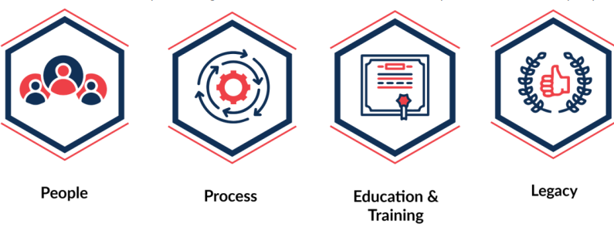
People: Foster a culture that prides itself on its commitment to proactive inclusion
Process: Create processes and practice that enable the workforce and student population to thrive
Education & Training: Ensure training and development opportunities are accessible and attractive to all
Legacy: Bring evidence-led EDI into the spotlight; to leave a footprint of positive and impactful change for our workforce, research participants and communities

Please reach out if you would like to more information or if we can support you.
Contact details
EDI lead  Leading on operations. | sayema.khan@nhs.net
EDI co-lead  Leading on strategy. | andrea.murray@manchester.ac.uk
EDI - CRF operational manager  NIHR Clinical Research Facility: Manchester EDI Lead | angela.kelsall@mft.nhs.uk
EDI co-ordinator | samman.mahmood@mft.nhs.uk

