BRC Information Governance (IG) tool kit
This tool kit was developed to provide research teams with the information and signposting they need to facilitate the information governance (IG) sign-off process for projects involving the University of Manchester. It has been developed in consultation with BRC research teams and the University of Manchester IG Office (IGO) and the Faculty of Biology Medicine and Health Research Governance Team (RGT). This guidance assumes that your research project requires a favourable opinion from a Research Ethics Committee (REC; most likely an NHS REC). It should be read alongside the BRC Sponsorship document.

Contents
Introduction 2
What is information governance? 2
When do I need to think about IG? 2
How do I get IG sign-off for a research project? 3
What is the order of operations? 3
Where to start when considering IG 4
IG risk review 4
Screening IGRR 4
Technical IGRR 4
Contracting 5
University of Manchester resources 6
External resources 7

Introduction

What is information governance?
Information governance (IG) encompasses the legal and regulatory requirements for working with data. In a research context, IG and research governance go hand in hand. To obtain a favourable opinion from the relevant Research Ethics Committee (REC), you will need to show that you have addressed IG considerations in your study design. Similarly, IG sign-off by the University of Manchester requires that you have REC approval in place if needed. IG also overlaps with Contracts, in that the specifics of data-sharing agreements will include details of how data is processed and by whom.

When do I need to think about IG?
IG is woven through entire research lifecycle, from the initial data management plan (DMP) draft that will likely be needed for a grant application, through to study archiving. As such, it needs to be considered at every stage and as an integral part of the project plan and execution.

The IGO and RGT work in tandem to ensure the necessary steps are completed ahead of a project being given the go-ahead to proceed. This is known as Sponsor green light, or SGL. There are three key points in the pre-submission and preparatory phases where IG is a particular consideration.

- Grant pre-submission period
Many grant-awarding bodies require submission of a DMP as part of the application. The University of Manchester requires that a DMP be completed for every research project, regardless of whether it is funded. DMPs are completed using the DMPOnline system and reviewed by the University library. The DMP includes questions on how data is created, stored, transferred and destroyed during the project. Any areas for consideration by the IGO will be flagged, and the IGO copied into the DMP feedback email sent to the researcher. DMPs are also used by the IGO to screen for IG risks that might arise as part of your project. Note that the IGO, Research IT, and the RG team can only offer support and advice based on what you put in the DMP, so it is vital that you include all relevant information.

- REC pre-submission period
Research involving human subjects and their data must undergo review by a REC. Part of the process of preparing a REC application includes consideration of IG. If your research involves individuals identified through their use of NHS services, it is likely that it will be the NHS REC that reviews your project. However, be aware that even if NHS REC is not required, your project may still require review by the University REC and/or HRA approval. If you are unsure if your research requires NHS REC review, the HRA decision tool will help and can be found here. Similarly, there is a UREC decision tool here (note: requires CAS authentication).

Submission to the NHS REC requires review by the research Sponsor (organisation with responsibility for the conduct of the study), and during this process . It may be that the IG questions raised do not have to be addressed prior to REC approval, in which case they will almost certainly require addressing ahead of Sponsor Green Light (SGL) being granted.

- Study setup phase (pre-SGL)
Before SGL can be issued, it is likely that any remaining IG issues will have to be addressed.

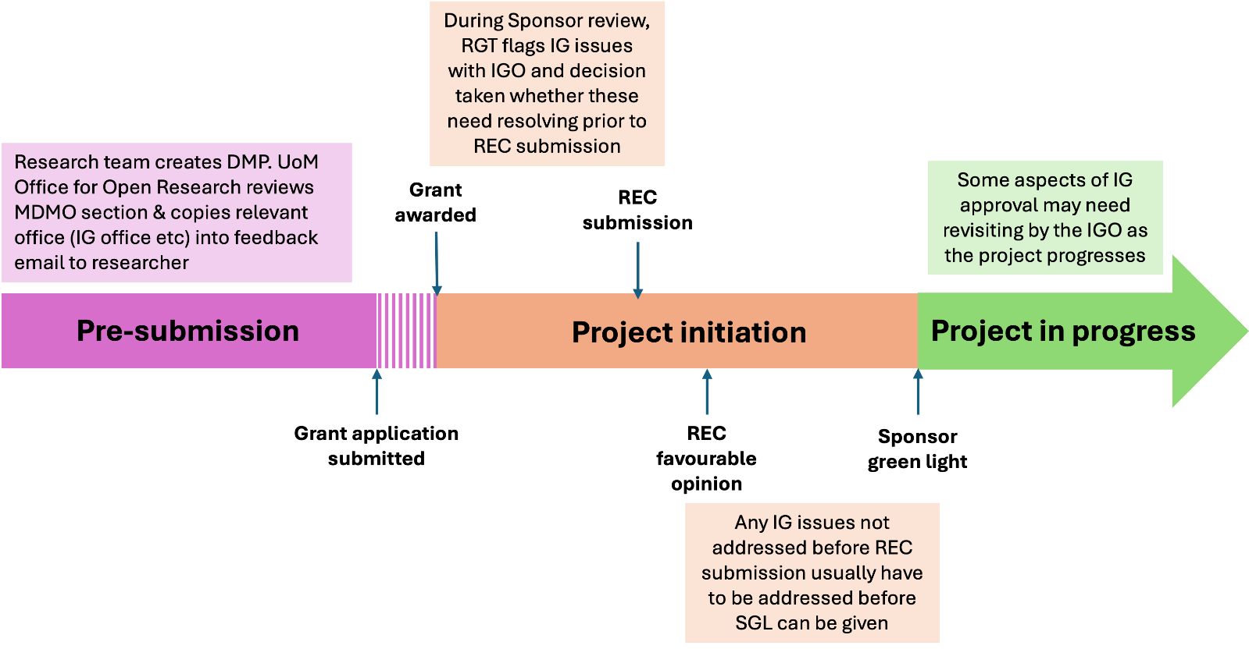
Figure 1. Section of the project lifecycle, divided into pre- and post-award information management activities. DMP = data management plan. MDMO = Manchester Data Management Outline. The MDMO prefixes all DMP templates and is reviewed by the University’s Office for Open Research. The Office provides feedback, usually within 1 working day, and copies the feedback email to any teams identified as relevant to your project (e.g. IG office, Research IT).

How do I get IG sign-off for a research project?
Briefly, the steps required to obtain IG sign-off are:

- Complete a DMP using DMPonline and submit for review
- The first section (MDMO) will be reviewed by the Office for Open Research (part of the University Library). The Office will put you in touch with the IG office if it identifies that you are processing or sharing data
- The IG office will use your DMP to complete a screening IGRR
- If the screening IGRR identifies the potential for significant risks to arise as a result of your research project, more detailed IGRRs may be required (e.g. technical IGRR)

These steps will be discussed in more detail below and in additional documents.

What is the order of operations?
For many aspects of project initiation / study setup, there is no set order of operations (although of course, you cannot start your research until everything has been signed off). The RGT and IGO work in parallel to ensure your project governance meets the necessary standards.

Where to start when considering IG
A sensible place to begin is to take the time to construct a flow diagram showing how data and samples will move between organisations during your research project. You may also wish to include the flow of funding for your own convenience. In this diagram, you should specify:
- Name of each organisation (e.g. The University of Manchester, Manchester University NHS Foundation Trust)
- The organisation’s role in the study, for example: participant identification centre, study site, lead organisation, study sponsor
- What type of data/samples are moving between organisations, and which do not move. For example, in a study where participants are recruited through NHS sites, it is usual for consent forms and the key linking study ID to a direct identifier (e.g. NHS number) to remain with the study site and be stored on a secure server or in a secure filing cabinet. In this example, it would be pseudonymised research data that moves from the study site to the lead organisation.
- How are data/samples moving between organisations? It could be that study teams enter data into the UoM instance of RedCap, it could be that data are sent by secure transfer. It is not recommended that data is transferred by email, but if this is done, it must be by secure email, e.g. using NHS.net email addresses

This will act as a quick reference for study details. It will also be helpful in conversations with Contracts, the IG Office, and Research Governance as it quickly conveys the most important project particulars. Including as much detail as possible on the flow diagram also means that you can see how IG fits into the broader picture of the project.

IG risk review
The cornerstone of the University’s IG sign-off process is the IG risk review (IGRR). The IGRR is used to spot any potential information risks in all projects, both research and non-research. The IGRR begins with a screening stage, which may be followed by a more detailed risk review if the IG office concludes the risks associated with your project warrant one. Note that the technical IGRR process can take several months to complete, so it is wise to start the process as soon as possible. It is also sensible to check in with the IG office as soon as possible to give them an overview of the proposed dataflows, so they can tell you if it makes sense in principle / identify any obvious red flags.

Screening IGRR
The screening IGRR is used to screen your project for IG risks. As of 24 June 2025, the IG office completes the screening IGRR form on your behalf, using the information in the project DMP.

You will need to go through at least the screening stage of the IGRR process if:
- You are working on an activity that involves processing or sharing information or data (even if it’s not personal data) OR
- You are getting a new IT system or updating an existing one which will be processing data

Technical IGRR
The Technical Security Assessment, also known as the technical IGRR, is required to be completed if your research involves using, building, or changing an IT system. This includes creating new dataflows that will come into University infrastructure. The technical IGRR is reviewed by the IT Security Team and the IG office. Please note that you can ask that third parties (e.g. collaborators) be added to the IGRR system so that they can also address queries. It is also likely that you will need support from Research IT to input responses. There is no expectation that project managers or other research team members will necessarily have the knowledge to complete a technical IGRR.

Technical IGRRs are created by the IGO and populated in OneTrust (accessible here: https://app-eu.onetrust.com/app/%23/module/welcome). OneTrust requires a UoM sign-on.

The technical IGRR asks questions about how your project meets the University’s Technical Security Standards (TSS), which define the University’s requirements for IT systems. The TSSs includes regulatory and legal requirements, as well as University-specific policies and procedures. They include:

- Cryptography: how data is protected in transit and at rest
- Vulnerability scanning and penetration testing
- Authentication: the processes used to prevent unauthorised access to systems, which include use of multifactor authentication (e.g. Duo) and credentials (e.g. username and password)
- Logging: how events within an IT system (such as users logging on or making changes) are logged and audited
- Password: the standards that passwords need to meet
- Patching: updates to IT systems that fix security vulnerabilities

Contracting
Every movement of data, funding, or materials requires a contract. Contracting is linked to IG because the details of how study information is to be managed, stored, transferred, destroyed and by whom need to be included in the contracts between study partners.

The most important thing you can do to smooth the process of getting IG sign-off is always to be as specific and detailed as you can when describing data and how it is processed.

University of Manchester resources

Document title | Link | Description
Information Governance Risk Review (IGRR) & OneTrust User Guide | https://documents.manchester.ac.uk/protected/display.aspx?DocID=44149 | User Guide for OneTrust (IGRR software). Explains how to navigate OneTrust
Using DMPonline to create a data management plan (DMP) | https://manchester-uk.libanswers.com/OOR/faq/278964 | Introduction to DMPs and how to create one
Writing a data management plan (DMP) | https://manchester-uk.libanswers.com/OOR/faq/278966 | How to write a DMP
Technical Security Standards | https://www.itservices.manchester.ac.uk/aboutus/policy/ (scroll down) | Defines the technical standards required for projects using IT

External resources
Information Commissioner’s Office

